Dissertation –Guide Feedback- July-Dec. 2015

Dissertation title :

Name of the Associate : Krishna Kumar G Associate ID: 355228 BITS ID:2013HT78070
Name of the guide: Karthikeyan Vedagiri

Designation of the guide: Sr. Manager

Mobile No. of guide: 95000 40683

E Mail ID of guide: Karthikeyan.vedagiri@cognizant.com

Guide’s individual opinion: (Please fill the below Questions)
1.Whether the Dissertation work is only that of the individual & not team /dept. work :
Only that of the individual.

2. Whether the Dissertation work is the work fully carried out in the period of Dissertation July-Dec. 2015
Yes.

3. Whether the student has brought out any thing useful to the organization or to the dept.:
Yes. The solution if implemented will ease the food ordering and distribution process in the organization.

4. How useful is it & is it implementable?
The solution is very useful. It will simplify the overall process of food ordering. Implementation will need approvals from various internal departments within the organization.

5. How practical & novel is the concept brought out?
The solution is very practical to bring down the time spent by the associates to order the food.

6. Does it involve any new technology?
Yes. It involves the use of the latest Restful technologies and AngularJS. The Mobile app is very handy that can be used by the associates.

7. Will the development work of this Dissertation can bring in tangible benefits to the organization:
Yes. It will improve the overall productivity of the associates. It will bring in a modernized and simplified approach for food ordering and will cut down long queues and wait periods.

8. Any Demonstration of Development work shown to you by the associate in connection with the dissertation work:
Yes. A detailed demo was shown.

Recommendation of guide :

Excellent. The work has been exceptional.

Excellent/Good/Fair/Poor

Signature of guide
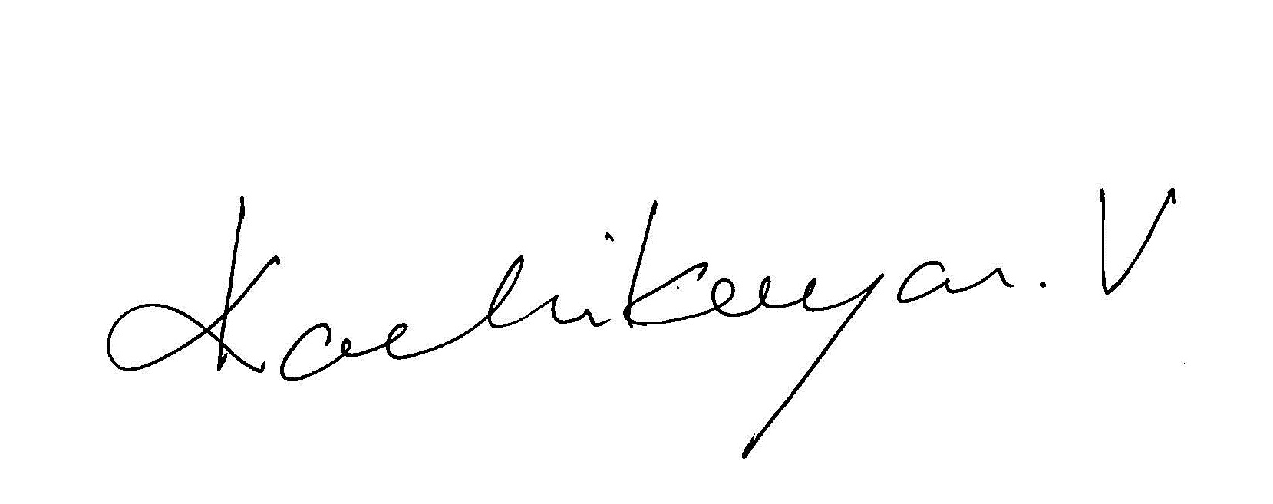
[ Karthikeyan Vedagiri]

